Subject Characteristics (rounded to the nearest tenths)
Table Subject characteristics
Variable | n = 195
VM (cm) (CI) | 41.2 (40.7-41.8)
KF_B (cm) (CI) | 24.7 (24.4-25.1)
KF_A (cm) (CI) | 13 (12.6-13.3)
Circ_A (cm) (IQR) | 36.2 (34.6-38.5)
Leg (left - right) | 95-100
Side (lateral - medial) | 96-99
Gender (female - male) | 96-99

MP | Frequency
1 | 195
2 | 193
3 | 143
4 | 89
5 | 2

The square dimensions are rounded to the nearest hundredths.
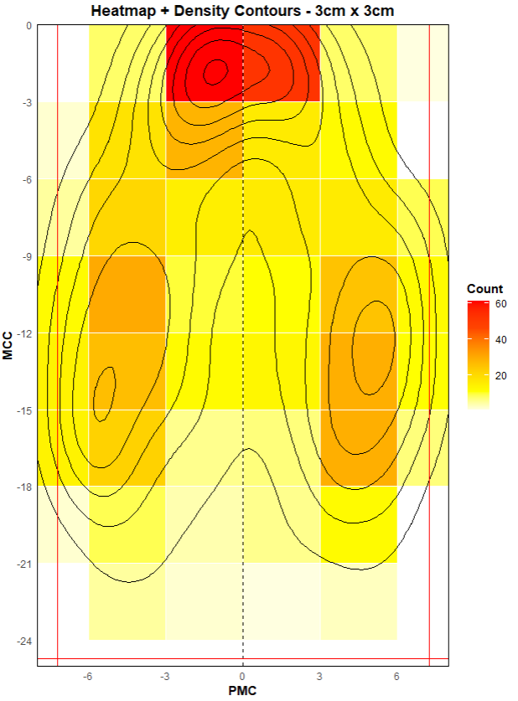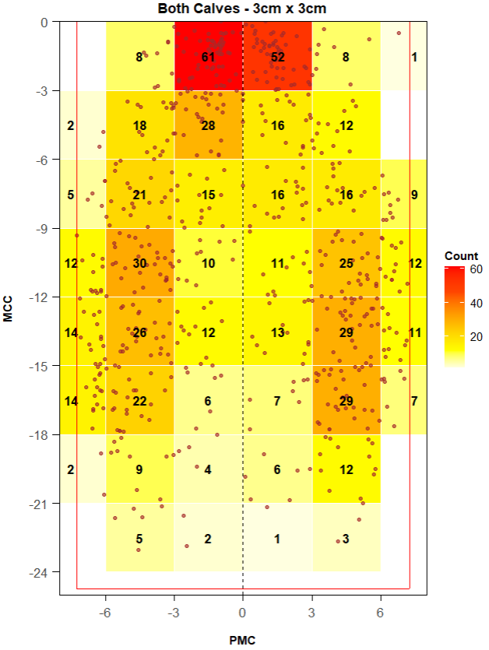
Cudrados Totales | 6 x 8
Cuadrados Vacíos | 5
Hexágonos Totales | x
Hexágonos Vacíos | x
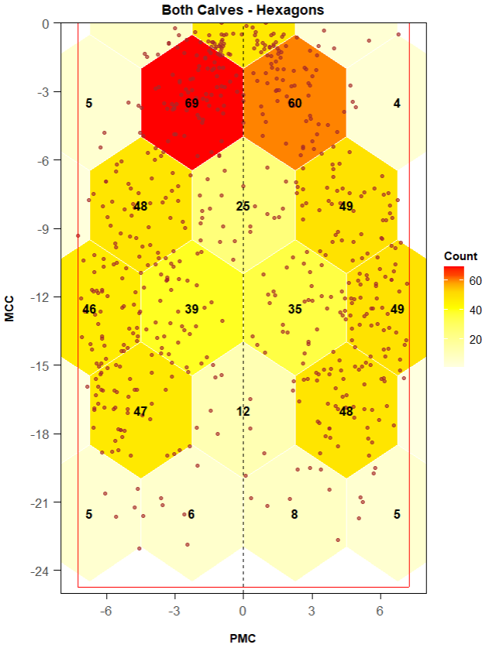

Zone 1 Area
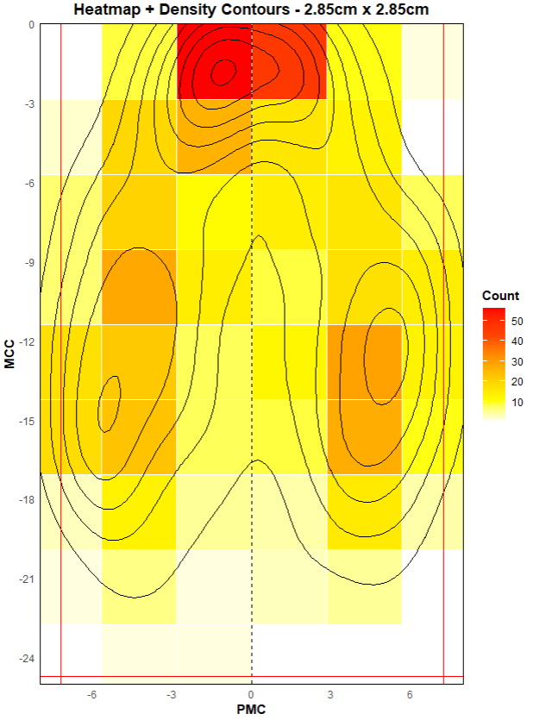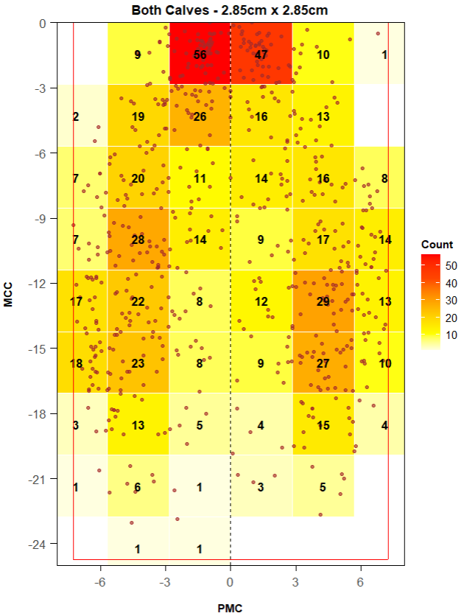
Cudrados Totales | 6 x 9
Cuadrados Vacíos | 7
Hexágonos Totales | x
Hexágonos Vacíos | x
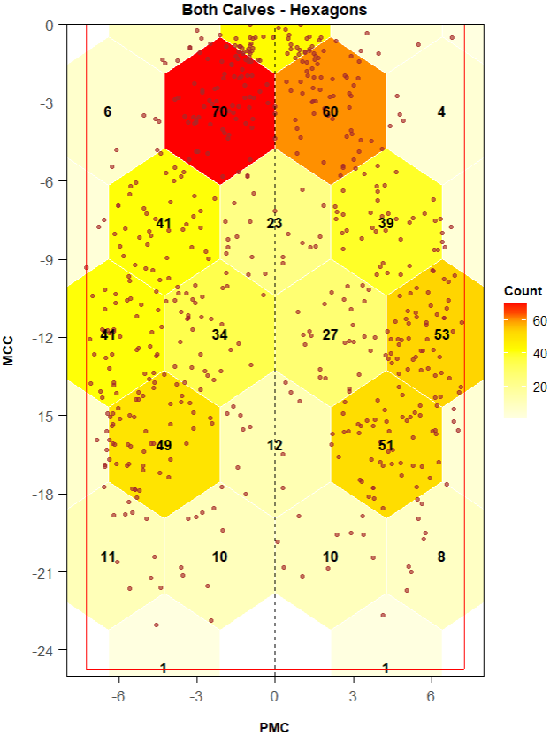

Zone 1 + Zone 2
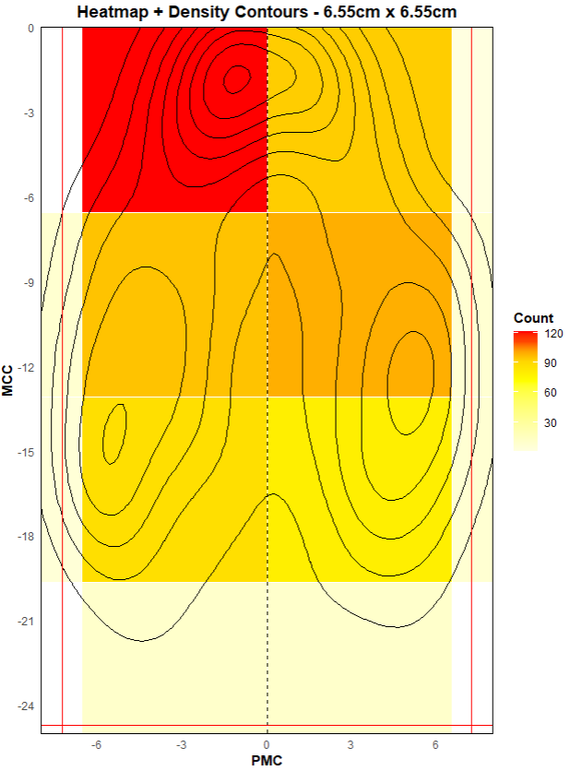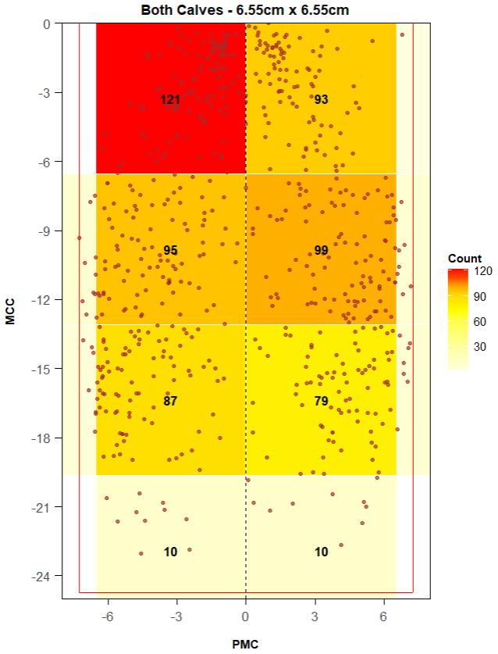
Cudrados Totales | 2 x 4
Cuadrados Vacíos | 0
Hexágonos Totales | x
Hexágonos Vacíos | x
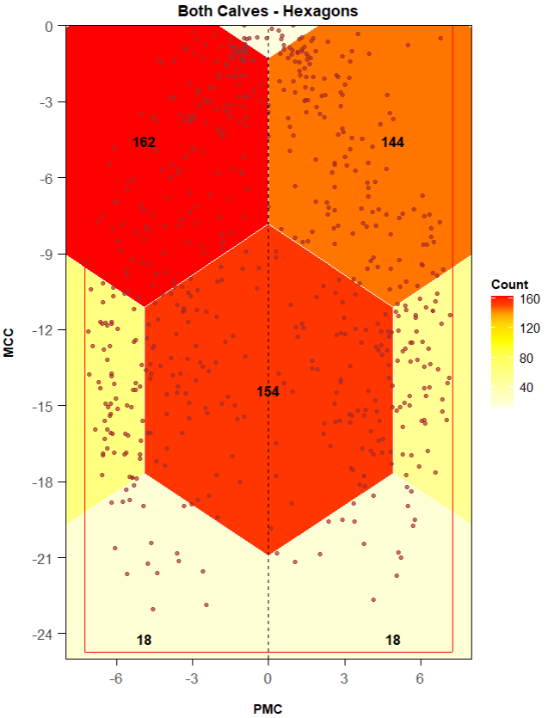

Sigma value = 1.2
